**ASSIGNMENT : JavaScript Variables | SUSHANT KUMAR | PH. NO. +91 9914207199 | sgbharat.joint@gmail.com**

**Problem statement:**

1. With your knowledge gained on Declaration of JS Variables using var, let and const keywords prepare a code that gives the following output.

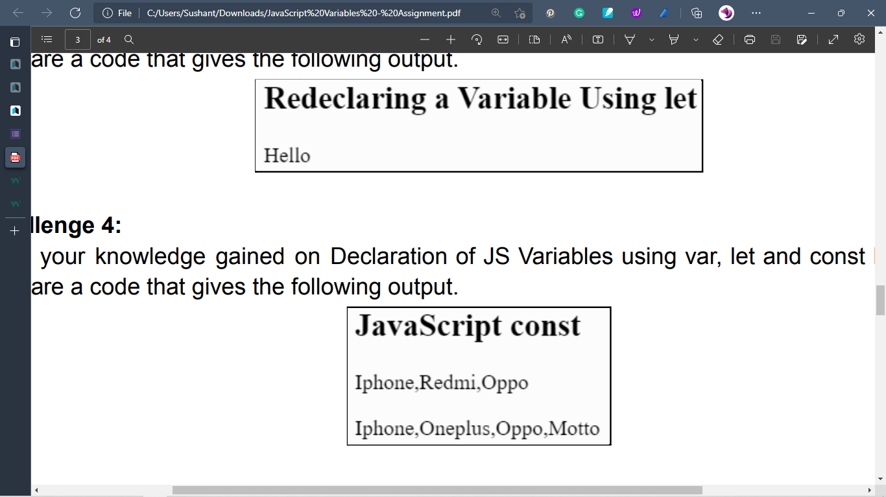

1. With your knowledge gained on Declaration of JS Variables using var, let and const keywords prepare a code that gives the following output.



**Solution:**

**Html Code:**

<!DOCTYPE html>

<html lang="en">

<head>

    <meta charset="UTF-8">

    <meta http-equiv="X-UA-Compatible" content="IE=edge">

    <meta name="viewport" content="width=device-width, initial-scale=1.0">

    <title>Javascript Variables</title>

</head>

<body>

    <!-- First task - Javascript Let usage-->

    <h1>Redeclaring a variable by using let</h1>

    <p id="para1"></p>

    <!-- Script file for first task -->

    <script src="variables.js" type="text/Javascript"></script>

    <br>

    <hr>

    <br>

    <!-- Second task - Javascript constant -->

    <h1>Javascript const</h1>

    <p id="para2"></p>

    <p id="para3"></p>

    <!-- SCript file for second task -->

    <script src="variables2.js" type="text/Javascript"></script>

    <br>

    <hr>

</body>

</html>

**JS Code:**

//script for first task

let declare = "Hello"; //declaration global

{

    let declare = "Hello People"; //declaration local

}

//value of declare outside brackets is still "hello"

//prinitng the final value of the declare

document.getElementById("para1").innerHTML=declare;

document.body.style.fontFamily="Candara";

//script for first task

//array declaration

const mobiles = [ " Nokia " , " Iphone " , " Samsung " ];

//prinitng the first array

document.getElementById("para2").innerHTML = mobiles;

//changing the array items

mobiles[1] = " Motorola ";

//adding items in the array

mobiles.push(" Redmi ", " Sony ")

//printing the updated array

document.getElementById("para3").innerHTML = mobiles;

**Output:**

